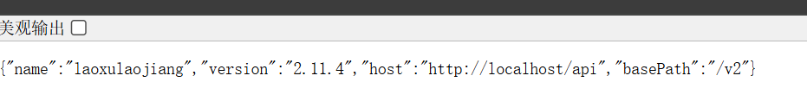

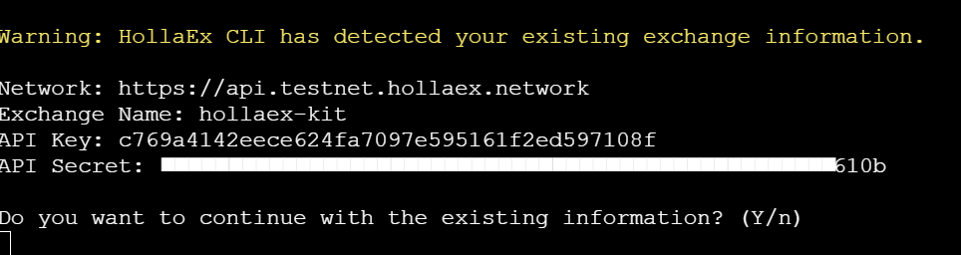

gcdqnmb@gmail.com
master1103

